**Designing process of Textile product**

**Author: Gouranga Basak**

**Version: 1.0**

1. Manual designing process

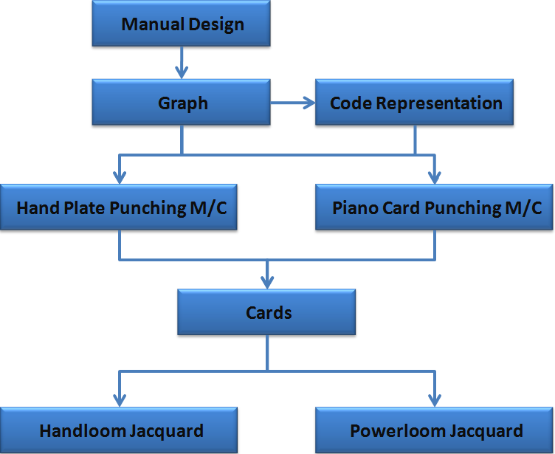

1. Computerized Textile design process using **TextileMan**

